Chapter 9, Problem 65.

Determine I and Z_{T} for the circuit in Fig. 9.72.

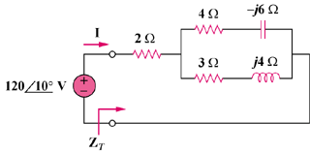

Figure 9.72
For Prob. 9.65.

